# Spoonacular

## Database

The database by the name ‘spoonacular’ has four tables; food, locations, menus, orders, restaurants and users.

Food

Has the following columns; id, username, food, created_at. id is the primary key. Saves favourite food for each particular user.

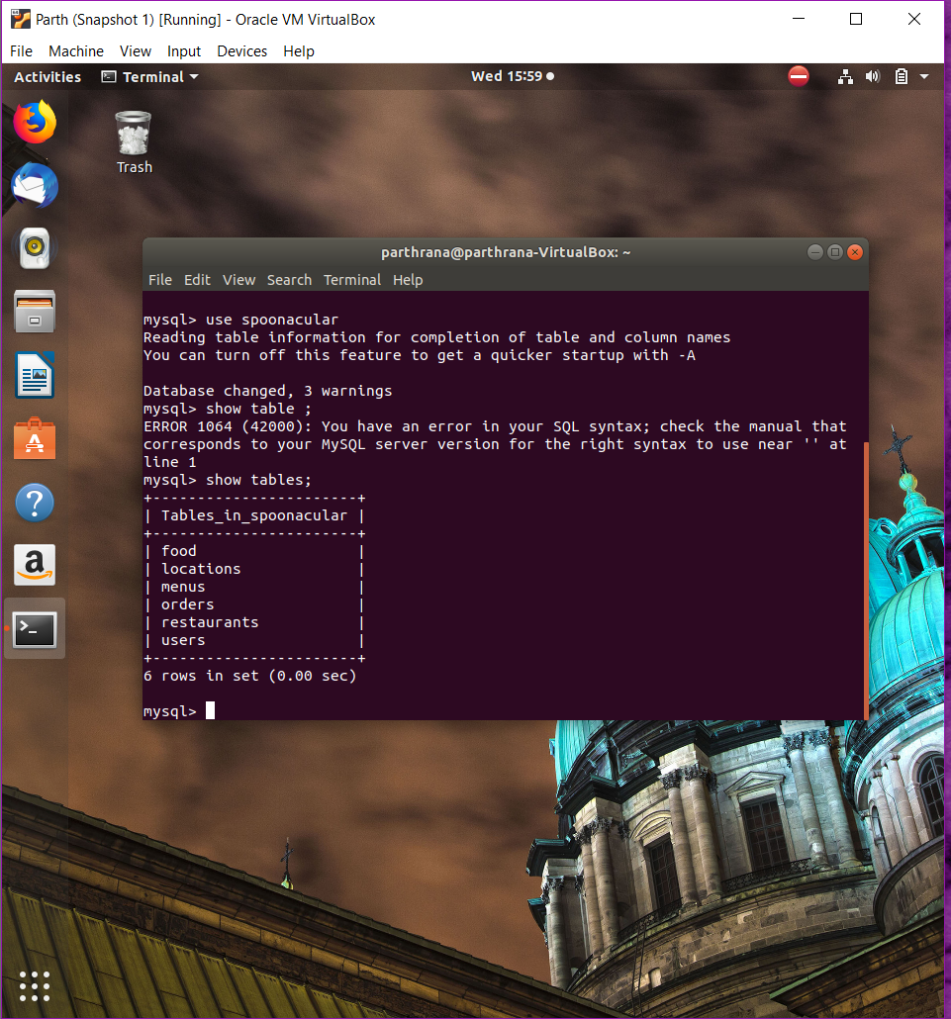

Locations

Has id and location as columns id is the primary key. Saves locations details.

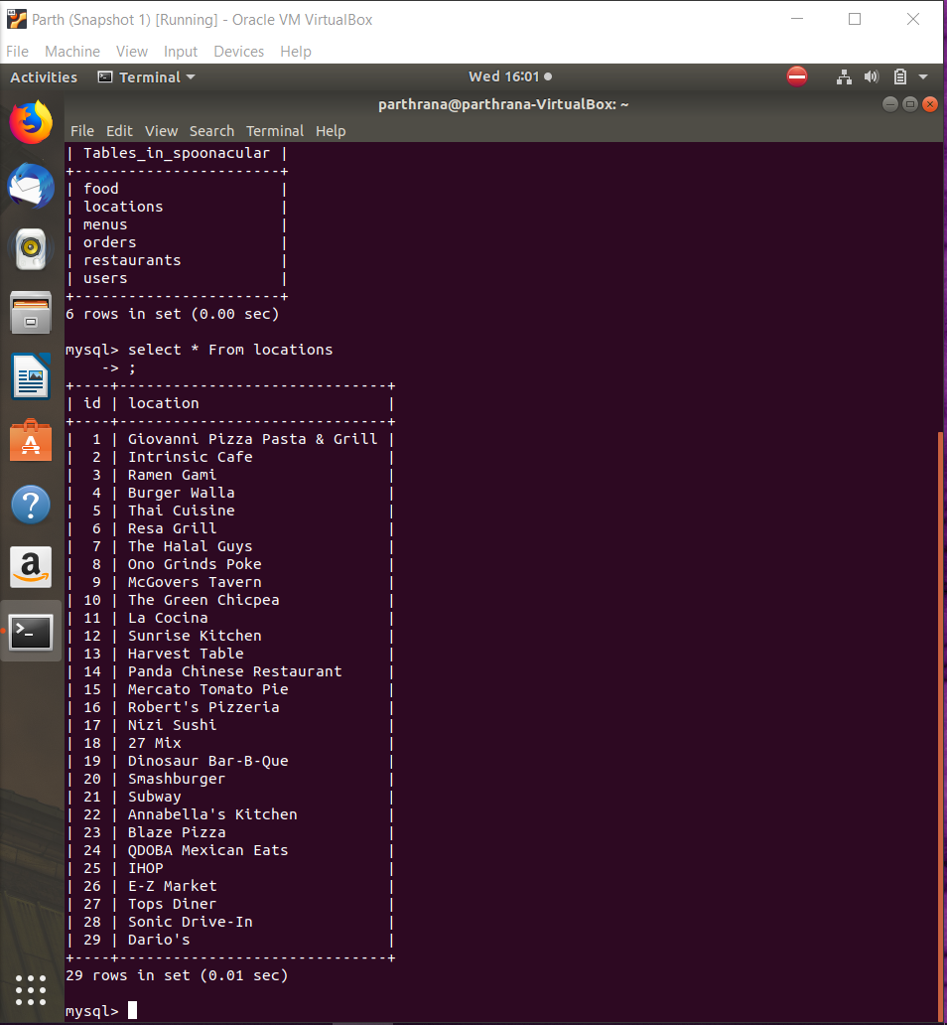

Menus

Has fields; id and menu as columns id is the primary key. Saves menus which is basically used to pull specific menu type from the Spoonacular API.

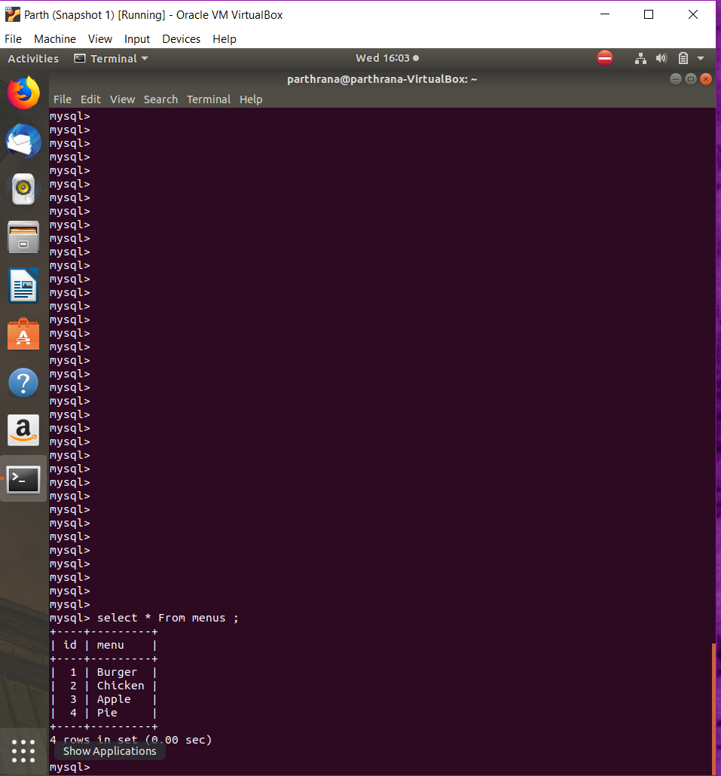

Orders

Has fields; Id, username, menu_name, created_at are its columns. id is the primary key. This saves details related to particular customer/user orders.

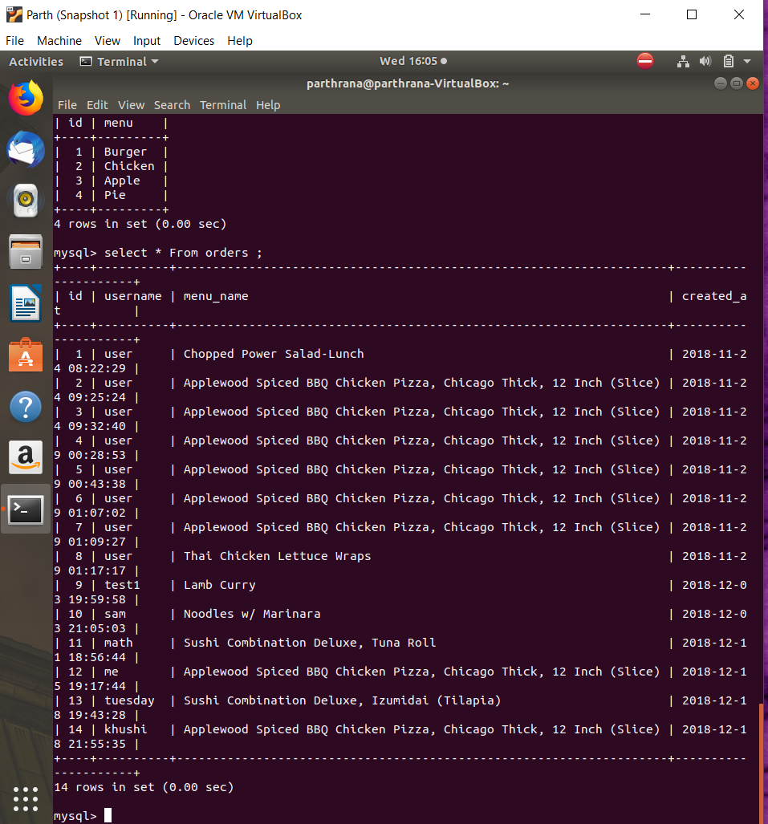

Restaurants

Has fields; Id, username, restaurant and created. id is the primary key. Used to save favourite restaurants for a particular user.

Users

Has fields; Id username, password & regdate are the columns. To save user data which is used to authenticate the users to the system.

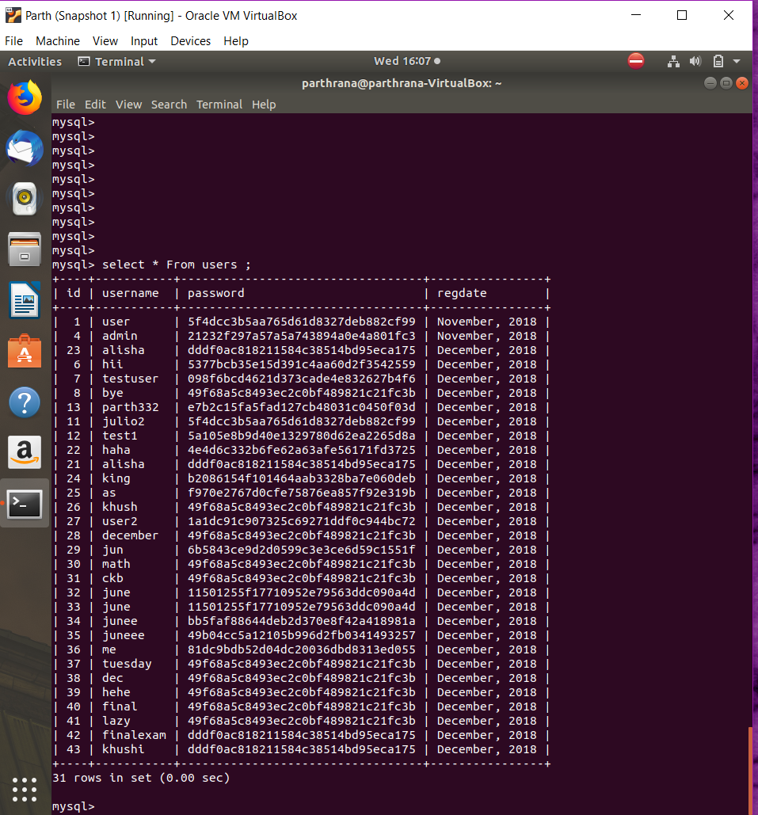

## Spoonacular API.

Using the api key and a menu name, the list of similar menu types are fetched giving out a json of each menu details that are then output on the html page. The list menu is limited to ‘search word’ applied. Below is the Javascript code that interact with the API. For the API to work the server hosting the system must be connected to the internet.

function getMenuItem($item){

require_once "./vendor/autoload.php";

// Disables SSL cert validation temporary

Unirest\Request::verifyPeer(false);

$response = Unirest\Request::get("https://spoonacular-recipe-food-nutrition-v1.p.rapidapi.com/food/menuItems/search?query=".$item."&offset=0&number=10&minCalories=0&maxCalories=5000&minProtein=0&maxProtein=100&minFat=0&maxFat=100&minCarbs=0&maxCarbs=100",

array(

"X-Mashape-Key" => $GLOBALS['key'],

"X-Mashape-Host" => "spoonacular-recipe-food-nutrition-v1.p.rapidapi.com"

)

);

return $response->body->menuItems;

}

function searchMenu($query){

require_once "./vendor/autoload.php";

// Disables SSL cert validation temporary

Unirest\Request::verifyPeer(false);

//fetch data

$response = Unirest\Request::get("https://spoonacular-recipe-food-nutrition-v1.p.rapidapi.com/food/menuItems/suggest?query=".$query."&number=5",

array(

"X-Mashape-Key" => $GLOBALS['key'],

"X-Mashape-Host" => "spoonacular-recipe-food-nutrition-v1.p.rapidapi.com"

)

);

return $response->body->results;

}

function getMenuInfo($id){

// Disables SSL cert validation temporary

Unirest\Request::verifyPeer(false);

//fetch data

$response = Unirest\Request::get("https://spoonacular-recipe-food-nutrition-v1.p.rapidapi.com/food/menuItems/".$id,

array(

"X-Mashape-Key" => "ZbwYt8rrzGmshEmlKAsALgc4U1Q5p1p33UKjsnO2MXpmdT4w8H",

"X-Mashape-Host" => "spoonacular-recipe-food-nutrition-v1.p.rapidapi.com"

)

);

return $response->body;

}

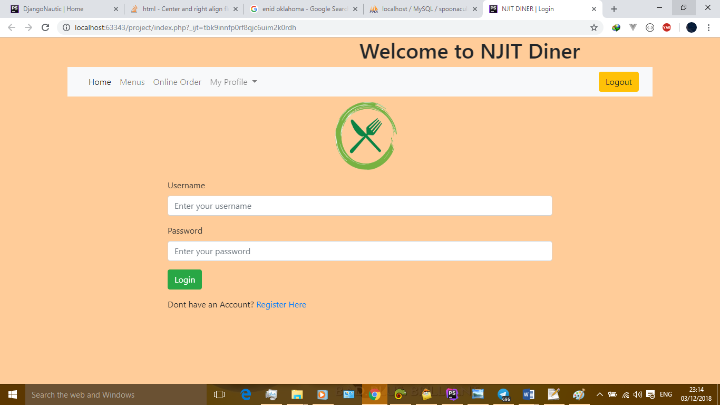

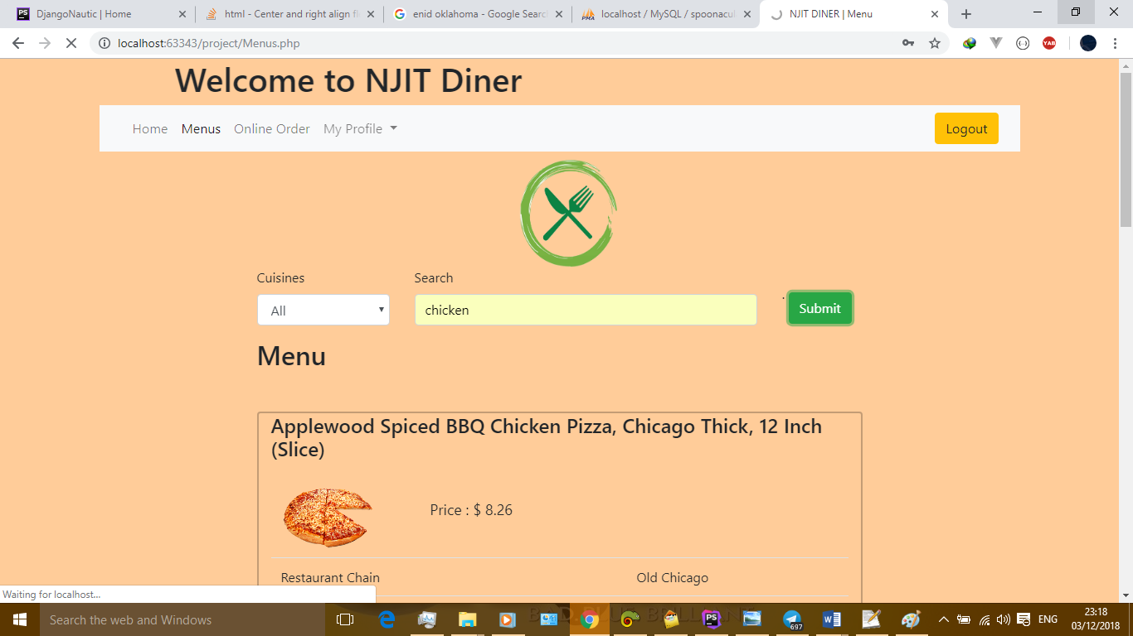

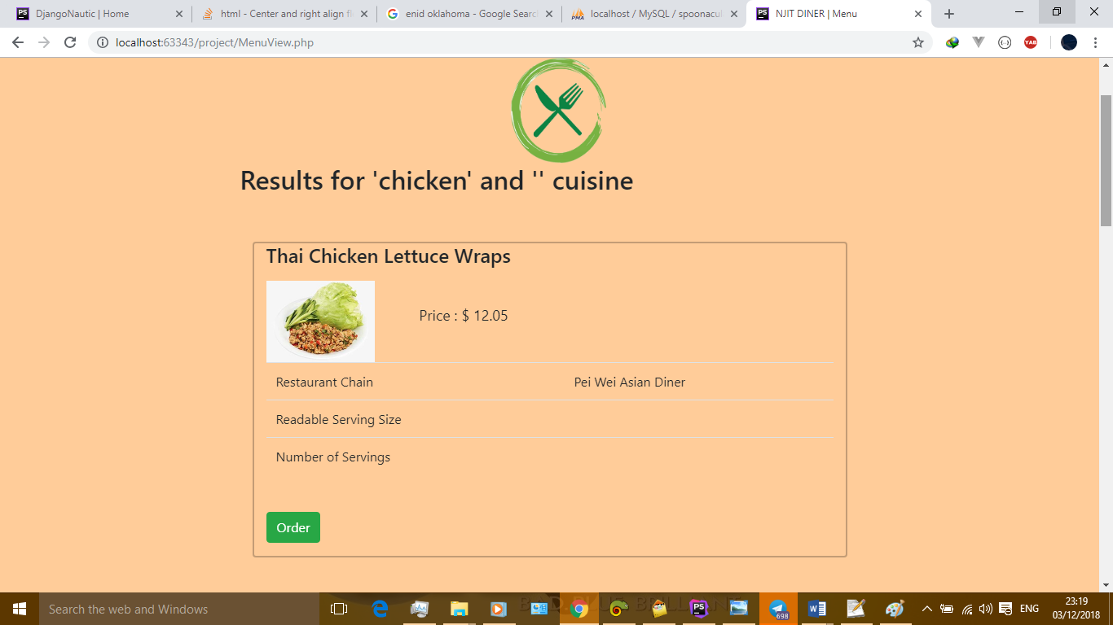

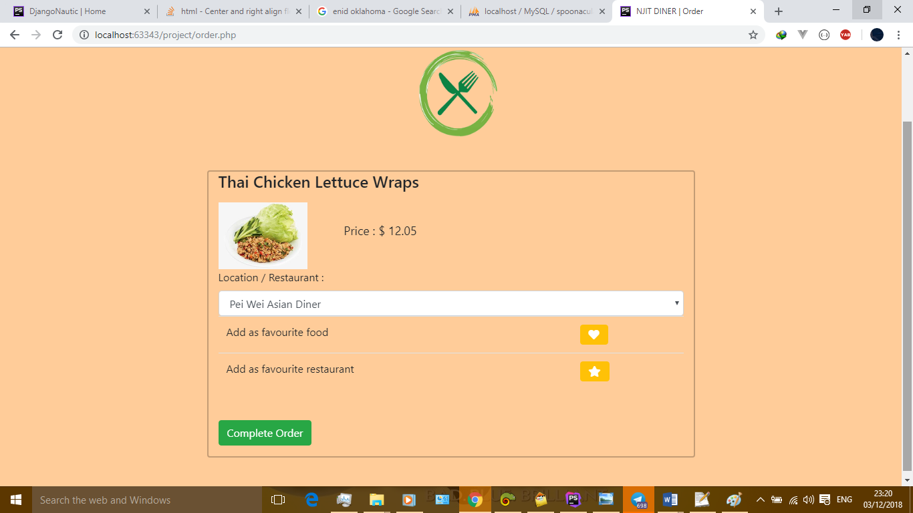

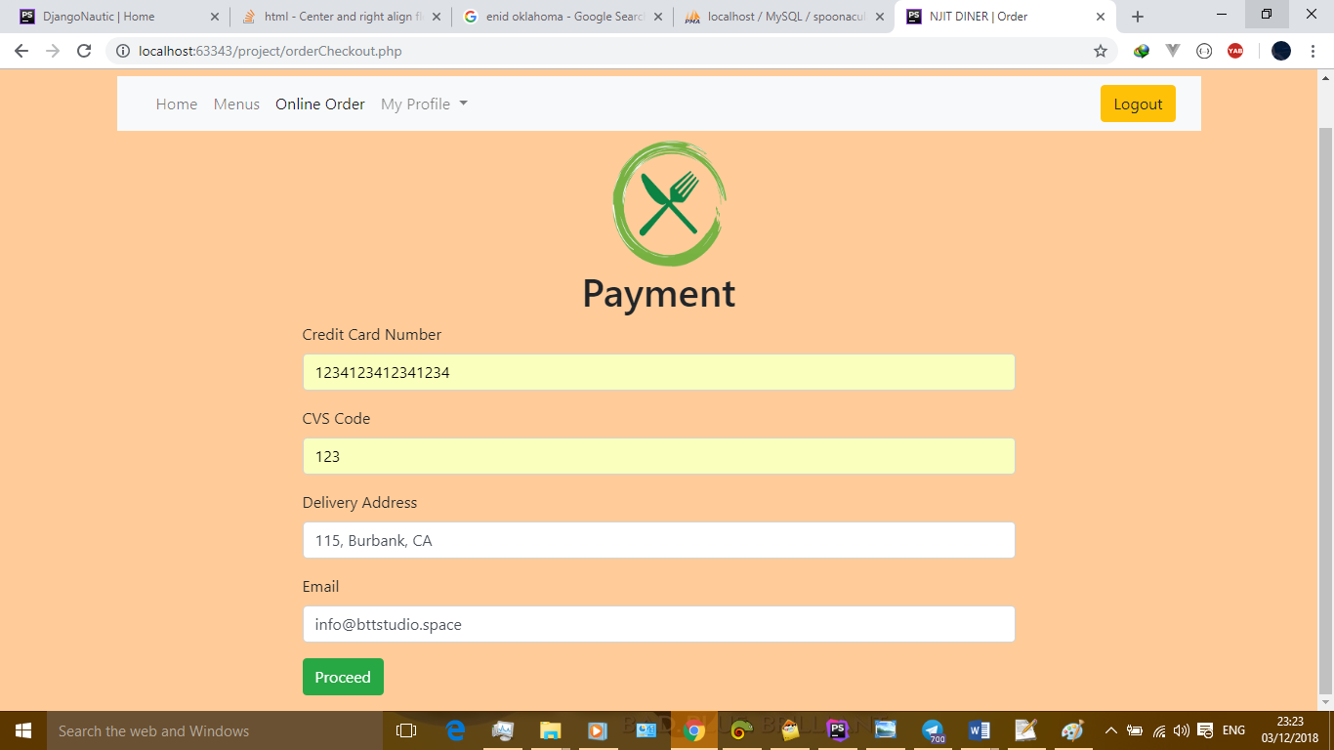

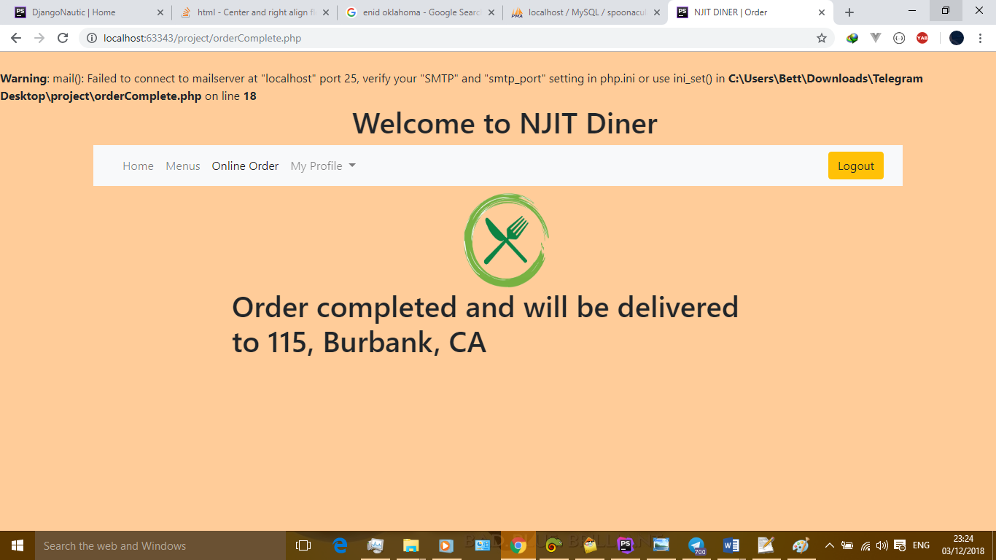

**References**

https://market.mashape.com/spoonacular/recipe-food-nutrition#autocomplete-menu-item-search